
Protocol – Reporting, Control and Monitoring of Repairs

INTRODUCTION
Owners and occupiers of premises have a duty to ensure the safety of employees and others who use them. Premises Managers/Line Managers have overall responsibility for ensuring venues are safe, whilst employees have a duty to ensure the safety of themselves and anyone who may be affected by their work. Where the Premises Manager/Line Manager is not based in a venue, duties will be assigned to a designated employee to ensure that the venue is safe in their absence. A key role of a designated employee is to report faults and monitor repairs on behalf of the Premises Manager/Line Manager.
- Premises Manager/Line Manager
The Premises Manager/Line Manager has a duty to ensure a venue is safe and systems are in place to ensure the safety of those using it. Premises Managers/Line Managers should undergo the following training on LearnPro to ensure they are aware of their responsibilities:
- Premises Managers Training
- Site Safety Awareness

- Designated Employee

In venues where the Premises Manager/Line Manager is not present certain responsibilities will be designated to an employee such as a Visitor Services Assistant, Sports Venue Assistant or Events Services Assistant.
It is the responsibility of the designated employee to ensure all faults are reported and dealt with within the allotted timescale. To ensure faults are noticed, the designated employee should ensure a Premises Checklist is completed each day the venue is open or when employees are present. This should be supplemented by regular walk around inspections of the venue and following any comments made by users. Any issues that are noticed or reported should be acted on by the designated employee.

Where venues are unmanned, such as Football Pavilions, it is the responsibility of the designated employee to ensure any faults are reported to the Premises Manager/Line Manager.

- Emergency Repairs

Emergency repairs are classed as those that are dangerous and the hazard it causes will affect the safety or security of the venue and occupants if it is not dealt with as soon as possible. Examples of this are:

- the intruder alarm cannot be set
- the emergency lights fail when there is not enough light in the building to safely evacuate it
- a broken window
- lose of heating throughout the venue

If the fault needs to be reported as an emergency, the designated employee should call the Facilities and Property Management helpdesk on 01563 555525 between 9am–5pm Monday to Thursday and 9am– 4pm Friday or call 0845 724 000 or 01563 553950 outwith these times (evenings and weekends).

It is essential that an employee stays at the venue until the emergency repair has been carried out.

- Technical and Specialist Knowledge

The designated employee is not expected to have an in-depth knowledge of construction, but they are expected to use their judgement on how a fault is dealt with. For example, if an area of floor is wet and can be cordoned off without being hazardous, it may be classed as a safety concern, but is still manageable in the short term.

The venue is still useable, but walkways around the venue may be restricted. As it is a safety concern it should be reported as an emergency repair.

In certain circumstances where it has been reported as an emergency and is not dealt with as such, because it is manageable it may be necessary to report it again if the condition worsens.

It is essential that faults are continuously monitored and any change reported to the Property Management helpdesk on 01563 555525 or the out of hours helpline 0845 724 000 or 01563 553950.

- Imminent Danger

The designated employee has delegated power to close a venue or an area within the venue should they feel it may be a source of imminent danger to employees, other users or the general public. Examples of this would be severe flooding or part of the structure is in danger of collapsing.

They should then contact the Premises Manager/Line Manager as soon as possible informing them of the issue and the reason for their decision.

- Non-Emergency Repairs

All other faults should be reported via the intranet at the following link: http://ealtintranet-stage.factory73.com/useful-links/ and monitored on a regular basis, any issues should be raised with the Premises Manager/Line Manager.

- Information Required when Reporting a Repair

The following information will help Facility and Property Management assess the repair:

- Site Details, e.g. AAA, Queens Drive, Kilmarnock,
- Location number of repair, e.g. Ladies toilet in location 001
- Detailed description of the repair – please include as much information as possible, including if any equipment is required e.g. Light out in Loc001 at ladies toilet. The light is a 4ft fluorescent light and will require a ladder or scaffold as its high level. We have no light bulbs on site.
- Contact details – a contact name and telephone number is required
- Access times/details – include opening hours and access details etc. so Contractors do not appear when the site is closed.
- Urgency of repair – emergency repairs must also be reported via the helpdesk. Please refer to Point 4 above.
- An attached photo of the fault, if it is safe to do so.

- Planned Maintenance

Planned maintenance is maintenance that has been agreed between East Ayrshire Leisure and Property and Facilities Management to ensure buildings remain fit for purpose and in a customer friendly state.

The Premises Manager/Line Manager will be informed of this in advance to ensure operational contingences can be put in place to avoid service disruption.

- Monitoring Progress

Live faults can be viewed on the Property Portal where the designated employee can monitor the progress of work by locating the venue.

Type the venue name into the property search box at the top of the page then click search. If your search for the venue is unsuccessful, type the name of the area it is located in and then chose the correct venue from those that appear.

Click on the venue name then on the ‘maintenance’ then ‘live repairs’ tabs.

- Information Provided

In the live repairs section the date the request was placed (Created Date) will be shown and its priority (timescales for completion) will be detailed. See below:

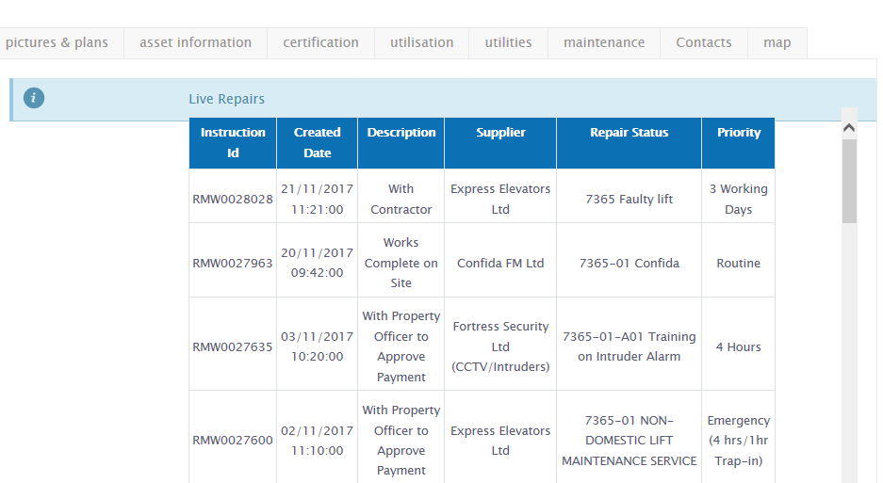

- Categories

The categories of repair and the timescales for completion are normally as listed below, there are some variations across the wide range of contracts:

• A – 4 hour response
• B – Completion within 3 working days
• C – Completion within 10 working days
• D – Completion within 20 working days
• E – Completion within timescale set by mutual agreement

Routine servicing and maintenance visits are those that have been arranged at the venue by Facility and Property Management and are essential to ensure the venue is compliant with the law. For example, annual servicing of boilers, lift maintenance etc.

The category each repair falls into will be decided by Property and Facility Management. However, the designated employee should checking whether a repair is progressing in the allotted timescale. If it appears to be overrunning they should phone the Property Services Desk 01563 555525 for an update. Thereafter, this information should be passed to the Premises Manager.

- Contentious Issues

If the designated employee feels the repair is not being dealt with quickly enough and believes it will affect service provision, they should let the Premises Manager/Line Manager know and they will decide whether to contact the Property Services Desk.

- Contractors

When a contractor visits a venue to carry out works they should complete the Monthly Works and Maintenance Monitoring Sheet

If the task has not been completed to the satisfaction of the designated employee they should call the Property Services Desk 01563 555525 and make them aware of the concern.

Record of Change:

Version | Authorised By | Date | Distributed To | Distribution Date
1 | People & Finance Manager | May 18 | All employees | Jun 18
2 | Head of Corporate Services | Apr 20 | All employees | Apr 20

