TASK /ACTIVITY / PROCESS DESCRIPTION: | Disposal of Needles - Sharps | DEPARTMENT/ SERVICE: | East Ayrshire Leisure
LOCATION: | Inside or outside Trust venues | REFERENCE:

TYPES OF INJURY / LOSS / ILL HEALTH  This should include injuries, acute and chronic ill health, psychological harm etc. For example, burns, fractures, bruising, lacerations, punctures, vibration white finger, occupational dermatitis, stress. | Infection  Injury through puncture wounds  Blood borne diseases
FOR EACH HAZARD, PLEASE IDENTIFY THE PERSON AT RISK (direct and indirect)
Consider those especially vulnerable (young/inexperienced workers, members of the public, school pupils, the elderly, residents and contractors).

 | HAZARD / SOURCE OF HAZARD | PERSONS AT RISK | CURRENT CONTROL MEASURES IN PLACE | Severity Rating  (1 – 5) | Likelihood Rating  (1 – 5) | Risk Rating  L/M/H  (1 – 25)
1 | Needle stick injuries  - Including exposure to blood borne viruses e.g. Hepatitis, HIV, AIDS. | Employees, bank workers, members of the public, volunteers, apprentices and Young People | - On discovery of a sharp, make the area safe i.e. cover with a bucket or similar and restrict access until uplifted.  - Only employees who have been trained, via toolbox talk, and are competent in the safe uplift and disposal of sharps will carry out this task.  - Follow the guidance within the Sharps Protocol for safe uplift of sharps  - If a trained employee is not present, contact supervisor to arrange for a trained person to attend the site as soon as possible.  - Always wear protective gloves and use the tongs/ grabbers provided.  - Take the sharps box to the location where it was discovered  - Store the sharps box in a secure location and arrange for uplift by the appointed contractor as necessary.  - Report a discovery of a sharp as a near miss on SHE  - In the unlikely event of a needle stick injury:  - gently encourage bleeding by squeezing but do not suck the wound  - Go immediately to the nearest Accident Emergency.  - Report on SHE as an accident  - If the sharp was found inside a building, spray the area where the sharp was discovered after disposal  - As a precaution spray the tongs/ grabbers with disinfectant spray after disposal  - Remove gloves and dispose of immediately after use.  - Wash hands thoroughly once gloves have been disposed of. | 4 | 1 | 4(L)

 | ADDITIONAL CONTROL MEASURES | Severity Rating  (1 – 5) | Likelihood Rating  (1 – 5) | Final Risk  Rating  L/M/H  (1 – 25) | Actioned By  (Print Name)  &  Target Date | Date Control(s) implemented | Sign to Confirm

ASSESSOR(s) PRINT NAME/JOB TITLE: | Hugh Collins  Development Officer: Sustainability | ASSESSOR(S) SIGNATURE: | 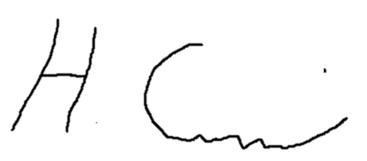 | ASSESSMENT DATE: | Feb 25
MANAGER PRINT NAME/JOB TITLE: | Jackie Biggart  Executive Lead: People, Policy & Performance | MANAGERS SIGNATURE: | 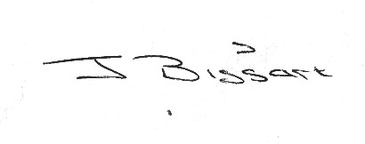 | REVIEW DATE: | Feb 25

ASSESSMENT REVIEWED BY: |  | REVIEW DATE: |  | REVIEW DUE:
ASSESSMENT REVIEWED BY: |  | REVIWE DATE: |  | REVIEW DUE:

