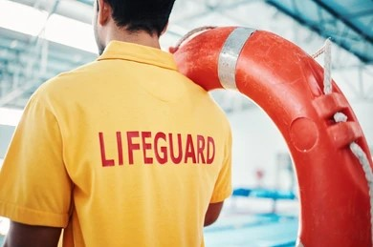  AQUA ZONE – ROLE OF A LIFEGUARD  Lifeguard Responsibilities Regarding Volunteers (AZ6.1)  - The Cambridge Dictionary defines a volunteer as, “a person who does something, especially helping other people, willingly and without being forced or paid to do it.”  - Who do we consider to be a volunteer in the Pool environment at the Galleon Centre?  - Clubs: Coaches, Swimming Teachers, Committee Members, Parent Helpers, Spotters, First Aiders  - Schools: Teachers, Parent Helpers, Classroom Assistants  - External Organisations: Carers and Support Staff  - The overall responsibility for everyone in the swimming pool, including these volunteers, lies with you, the Lifeguard. You are responsible and have a Duty of Care for the safety of everyone in the pool, you are in charge, and you make the decisions by following the rules and responsibilities set out in your training, the Galleon Centre Risk Assessments & our PSOP.
  GALLEON CENTRE
  99 Titchfield Street
  Kilmarnock
  KA1 1QY
  SC008314
  www.galleoncentre.com

