
- OBJECTIVE AND SCOPE:

Health & Safety Standard, Working at Height is one of a number of documents, forming the Trust’s Health, Safety and Wellbeing Policy written arrangements in compliance with general duties under the Health and Safety at Work Act 1974 and the Management of Health and Safety at Work Regulations 1999

This standard outlines the arrangements in place to protect against the risks associated with working at height and related specifically to the Work at Height Regulations 2005.

- RESPONSIBILITY:

Overall responsibility for this standard belongs to the Senior Management Team. Managers are responsible for ensuring local arrangements are fully implemented within their areas of control.

Operational responsibility belongs to Managers and Officers who must ensure that adequate arrangements are in place to manage the risks associated with work at height and that all activities associated with work at height are suitably assessed and controlled.

The Health and Safety Strategy Group will provide further information and advice if required.
AUTHORISED BY: Chief Officer
DATE: June 2025
CONTENTS

1 INTRODUCTION 4
2 DEFINITIONS 4
2.1 Work at Height 4
2.2 Working Platforms 5
3 DUTIES AND RESPONSIBILITIES 5
3.1 Management Responsibilities 5
3.2 Employee Responsibilities 6
4 CONTROLLING THE RISKS FROM WORK AT HEIGHT 6
4.1 Risk Assessment 6
4.2 Assessment of Work Area 6
4.3 Fragile Surfaces 7
4.4 Falling Objects 8
4.5 Collective Protection Measures Versus Personal Protective Measures 8
4.5.1 Collective Protection Measures 8
4.5.2 Personal Protective Measures 8
5 WORKING AT HEIGHT EQUIPMENT 9
5.1 Ladders and Stepladders 9
5.1.1 Typical Use 9
5.1.2 Identification of ladders and stepladders 10
5.1.3 Loan or lease of ladders and stepladders 10
5.2 Trestles 10
5.3 Mobile Elevated Working Platforms (MEWPs) 10
5.4 Mobile Scaffolding Platform 11
5.4.1 Precautions and inspections 11
5.5 General Access Scaffold 12
5.6 Roof Work 13
5.7 Harness/Lanyards 13
5.8 Tallescopes 14
5.9 Emergency Resuce Procedures 14
6 INSPECTIONS 14
6.1 Inspections of Ladders and Stepladders 14
6.2 Visual Inspection by User 15
6.3 Inspection Recording 15
6.4 Inspections of Existing Places of Work 15
7 INFORMATION, INSTRUCTION & TRAINING 16
8 FURTHER INFORMATION 17

Appendix 1: Ladder/Stepladder Inspection Requirements 18
Appendix 2: Ladder Inspection Checklist 19
Appendix 3: Stepladders Inspection Checlikst 20

- INTRODUCTION

Falls from height remains one of the main causes of death and major injury in the workplace. This standard provides procedural guidance to ensure that suitable and sufficient controls are in place to eliminate or minimise the risks of falls from height within Trust workplaces.

The Trust has a duty under the Health and Safety at Work etc. Act 1974 and the Work at Height Regulations 2005 to protect employees and others carrying out work on their behalf, such as contractors, against the risks associated with working at height.

This will be achieved by ensuring that there are safe systems in place for work at height, including the provision of suitable equipment to allow safe access to and egress from the place of work.

Arrangements must be put in place to ensure the contents of this standard are fully implemented and communicated to employees who are responsible for planning, supervising or carrying out any work at height. This must include having suitable and sufficient risk assessments for the work activity, which must be communicated to those supervising and carrying out the work.

In addition to the general requirements for working at height, this standard has been developed to include guidance on the safe use of ladders, stepladders and other items of work equipment which are used by Trust employees.

DEFINITIONS

  - Work at height

‘At height’ can be defined as any area where a person could be injured by falling from it, including an area at or below ground level.

Work at height does not include slips and trips on the same level or falls on staircases within a permanent workplace e.g. a building. The fall must be from a higher to a lower level. There is however no minimum height requirement, for a fall to be classed as ‘from height’.

Work at height could arise from working in a number of different situations, for example, working from:
    - Working platforms
    - Roofs
    - Ladders or stepladders
    - Cradles
    - Machines, plant or vehicles
    - Trees
    - Street lights
    - Next to an excavation

  - Working Platforms

A working platform can be any elevated surface on which work is carried out or is used as a means of access to or egress from a place of work. For example:

    - Scaffold
    - Cradle
    - Trestle
    - Mobile Tower
    - Mobile elevated working platform
    - Podium steps

A working platform can be considered safe, providing measures have been taken to control the risk. For example, scaffolding is a safe working platform provided it is correctly erected, inspected, is appropriately guarded and users are trained in its use. Those erecting certain work platforms must put in place suitable fall mitigation during their construction.

3. DUTIES AND RESPONSBILITIES

3.1 Management Responsibilities

The duty holder i.e. the person in charge of the job/ site must ensure that:

    - Work at height is avoided, where possible,

    - All work at height is properly planned and organised with a suitable risk assessment completed and communicated to those supervising and carrying out the work,

    - All persons working at height are appropriately trained and competent for the tasks carried out and for any work equipment being used,

    - All working platforms which require to be constructed, such as scaffolds and mobile towers, are only erected by appropriately trained and qualified personnel,

    - Any equipment used is appropriately inspected and certificated. This will include the removal of any defective or sub-standard equipment from use,

    - The risks from fragile surfaces are properly controlled. This will include the proper identification of all fragile surfaces.

3.2 Employee Responsibilities

Employees or those working under someone else’s control i.e. contractors must:

    - Report any unsafe activity or defective equipment to their supervisor/manager immediately,

    - Use any work equipment or safety devices provided in accordance with training or instruction received,

    - Use the appropriate access equipment for the task when working at height,

    - Report any unsafe conditions, incidents or near misses to their supervisor/manager immediately.

4. CONTROLLING THE RISKS FROM WORK AT HEIGHT

4.1 Risk Assessment

This simple hierarchy for managing the risk from work at height must be followed:

Avoid work at height wherever possible - if this is not possible, then:

    - Use work equipment or other measures to prevent a fall, so far as is reasonably practicable
    - Where the risk of a fall cannot be prevented, use work equipment or other measures to minimise the distance and consequences of a fall, should one occur
    - Give priority to collective fall protection measures over individual protection measures.

4.2 Assessment of work area

When assessing the conditions within the working area the following should always be considered within the risk assessment process:

Site conditions: slopes, unstable ground conditions, obstructions and traffic will affect the type of work equipment used. Consideration must also be given to items such as cellars, chambers, drains and covers.

Outdoor work: must always take account of weather conditions which may increase the risk to health and safety. The presence of overhead cables must be considered when erecting or dismantling working platforms, including ladders.

Access/egress: any equipment used for access/egress must be suitable and sufficient to allow safe working and passage of persons and materials at all times. For example, ladders are less suitable for higher levels, especially when there are a number of people requiring access with materials.

    - Risks when installing/dismantling equipment: proper controls must be put in place when installing or dismantling equipment for work at height. This may include individual fall protection for those involved.

    - Protection of the working area: suitable controls may be required i.e. barriers/fencing, road occupation permits etc., to ensure adequate segregation of the working area from traffic and/or pedestrians.

    - Distance and consequences of a fall: suitable and sufficient means for preventing a fall must be in place with no surface gaps through which a person or materials could fall.

    - Evacuation and rescue: how persons would be evacuated and rescued in the event of an emergency must be considered and implemented.

    - Loading requirements: the stability and strength of the work area must be assessed to establish loading capabilities, including the identification of any fragile surfaces.

4.3 Fragile Surfaces

A fragile surface is one that could collapse if it cannot sustain the weight placed upon it. Some examples of fragile surfaces include asbestos cement tiles, skylights and unstable roofs.

No person will work on, over or close to a fragile surface where it is possible to carry out the work safely by some other reasonable means. Where it is not possible to carry out fragile surface work by other safer means, then the following must be considered:
    - The use of protective platforms
    - The use of protective coverings
    - The use of guard rails

All fragile surfaces must have prominent warning notices (figure 1) affixed at the approach to the surface and at other suitable locations identifying the surface as dangerous. If this is not possible then some other means of notifying people of the fragile surface must be implemented.
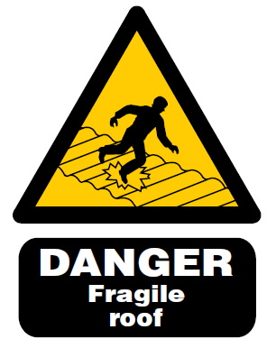

Figure 1 – Typical fragile roof sign

4.4 Falling Objects

Workplaces at height must be kept clear of loose material to prevent materials/objects falling from height. Materials and plant must be safely stored to avoid the risk of overturning or collapse.

The use of barriers, such as toe boards, brick guards, fans and debris nets should be implemented as required to prevent people from being struck by falling objects.

If the workplace contains an area in which there is a risk of someone being struck by a falling object, the area must be cordoned off to protect any persons who may be at risk of injury.

Warning signs must be clearly displayed to prevent access by unauthorised people to areas where there is a risk of injury and to provide warning information and instructions to people working on, or visiting the site.

  - Collective Protection Measures Versus Personal Protective Measures

When considering the benefits of collective protection versus personal protective measures, managers/officers must give consideration to the working conditions likely to be encountered and the risks to the safety of persons using the associated work equipment. If the specified work equipment is used for access and egress, such as ladders or step ladders, then there should be consideration for the distance to be negotiated and the consequences of a potential fall.

    - Collective Protection Measures

Collective protection measures are systems which provide fall protection for everyone working in that particular environment. For example, a scaffold used as edge protection around a flat roof would be classed as a collective fall protection measure. Collective fall protection measures must be given priority over the use of personal protective measures.

    - Personal Protective Measures

Personal protective measures are those controls put in place when the use of collective measures cannot be achieved. Items such as a full body harness, positional or absorbing lanyards, inertia reel and other such items would be considered as personal protective measures. All equipment of this nature must be inspected prior to use and receive a thorough inspection on a six monthly basis, which must be recorded. If any defects are observed such as fraying, splits etc. then it must be removed from service immediately for repair, where possible, or destruction.

5. WORKING AT HEIGHT WITH EQUIPMENT

5.1 Ladders and Stepladders

5.1.1Typical Use

Ladders and stepladders must only be used:
      - After a pre-use check (stiles, rungs and feet are in good repair and clean)
      - For short duration work that is no more than 30 minutes
      - For light work (unsuitable for strenuous, repetitive tasks, continually carrying heavy materials)
      - When resting on a firm, level surface
      - When placed as one out for every four up (leaning ladder) (figure 2)
      - If it allows 3 points of contact for the user (leaning ladder) (figure 3, 5)
      - When the top of the ladder rests against a solid surface
      - If it’s fit and long enough for the proposed task
      - If locking devices can be fully opened and engaged (figure 4)
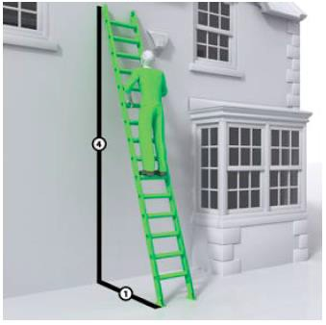
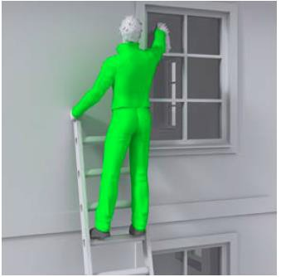
1

Figure 2 – 1 in 4 ratio for leaning ladder
Figure 3 – Maintain 3 points of contact

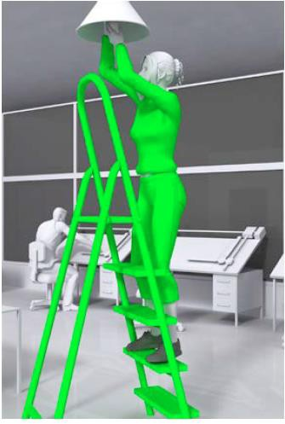
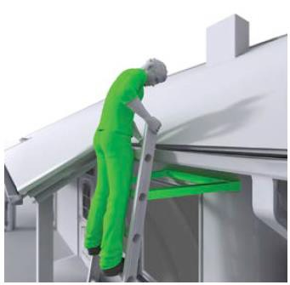

Figure 5 – Example where two hands needed for light work. 3 points of contact maintained (chest, knees and feet)
Figure 4 – Ensure standoff devices are secured and locked.

For longer duration work or where the working area is more than 2 meters in height, more suitable forms of access equipment should be considered, such mobile platform towers and scaffolding.

5.1.2 Identification of ladders and stepladders

Departmental arrangements must be in place to ensure that every ladder/stepladder and any associated equipment used in connection with work at height is clearly identified.

A Ladder Register should contain the following information:
      - Equipment Serial No(s)
      - Type and description of equipment
      - Name and designation of inspector and/or company name
      - Date of inspection and review dates
      - Results of inspection
      - Details of any defects and repairs

Where equipment has been identified as defective it should be removed from use immediately with service markings deleted. The equipment should also be placed in a secure location to await repair or disposal.

On completion of any repair, the equipment will be subject to inspection and the current service markings applied before allowing its use.

5.1.3 Loan or lease of ladders and stepladders

Ladders, stepladders, trestles and other access equipment owned by the Trust must not be provided for use by non-Trust personnel or agencies.

  - Trestles

Trestles should be regarded in the same way as ladders or step ladders, for temporary and lightweight use only. Always ensure any locking mechanisms are utilised prior to use.

Do not climb upon trestles as they are not a substitute for a ladder/step ladder. Prior to trestle use, check that there are no loose or missing screws and bolts, no splits, warping or decayed or broken parts. If the trestles are defective, report immediately and remove for repair/replacement.

5.3 Mobile Elevated Working Platforms (MEWPs)

As with all equipment used for working at height, the risks associated with the use of MEWPs must be identified, controlled and communicated to those carrying out the work.

MEWPs must be set up on a suitable surface with outriggers deployed. Where necessary, the working area must be restricted from public access by the use of barriers and signage.

Operators must wear the appropriate fall restraint harness and lanyard, including all relevant PPE at all times. The only exception to this is where work is taking place close to water bodies i.e. rivers, lakes and ponds.

Note: It is highly unlikely that there will be a need to leave the cage of the MEWP whilst it is raised at height. However, if there is a need to leave the cage then a suitably detailed risk assessment is required.

5.4 Mobile Scaffolding Platform

A tower scaffold must be suitable for the intended work. It must also be erected and dismantled by trained and competent people, who are also aware of the potential dangers and required precautions.

The use of tower scaffold provision must include rigorous scaffold inspection arrangements.

The manufacturer or supplier has a duty to provide an instruction manual explaining its safe assembly. The tower’s stabilisers or outriggers must be installed as detailed in the instructions, with the tower never being erected above its recommended height.

The tower must be located on firm, level ground with the locked castors or base plates properly supported. Never use bricks, building blocks or other materials to take the weight of any part of the tower.

5.4.1 Precautions and Inspections

Tower scaffolds must comply with the standards required for all types of scaffolds, e.g. double guardrails, toe boards, bracing and access ladder. When the tower is purchased or hired it should arrive with all the necessary components to ensure stability, strength and prevent falls.

After assembly all towers must be inspected by a competent person, then again at suitable intervals. If an inspection identifies a fault, works must be stopped until the fault is resolved. The inspection record should be held until superseded by the next inspection.

Services must put in place a suitable means of recording and monitoring hired equipment in order to ensure that any equipment on-hire is returned and replaced before the next due inspection date.

Make sure everyone involved is aware of, and follows, these simple rules:

Never use a tower:
      - In strong winds
      - As a support for ladders, trestles or other access equipment
      - With broken or missing parts
      - With incompatible components

When moving a tower you must always:

      - Reduce the height to a maximum of 4m
      - Check that there are no power lines or other obstructions overhead
      - Check that the ground is firm, level and free from potholes; and
      - Push or pull using manual effort from the base only

Note: Never move a tower whilst people or materials are on the tower, or in windy conditions.

For further information on the safe systems for assembling mobile scaffold towers, visit the HSE’s web page on Tower Scaffolds

5.5 General Access Scaffold

A general access scaffold can provide safe access to roof level and a working platform around the edge of the roof, as well as providing space to store materials. Often, a loading bay can be erected to help materials handling and transfer on a roof.

A scaffold must:
- Be designed, erected, altered and dismantled by competent people only and the work carried out under a competent supervisor.
- Never be erected or dismantled over people or busy pavements. A road or pavement closure should be applied for when work presents danger to the public, to help reduce any associated risks. If this is not granted, erection and dismantling must be done inside a segregated area and during times when there are fewer members of the public in the vicinity.
- Be based on a firm, level foundation. The ground or foundation should be capable of supporting the weight of the scaffold and any loads likely to be placed upon it. Be aware of any voids, such as basements or drains, and patches of soft, uneven ground, which could collapse when loaded. Provide extra support as necessary.
- Be braced and tied to a permanent structure or otherwise stabilised. Proprietary system scaffolds must be erected and tied in accordance with the manufacturer’s instructions.

On sites where people from more than one trade are working, the principal contractor and the roofing contractor must agree what is necessary and who will provide it. They must also agree who will carry out the necessary statutory inspections. Scaffolds used by contractors working on behalf of the Trust are also subject to inspections by the appointing Service and the Health & Safety Section.

5.6 Roof Work

For roof works, edge protection should always be erected at eaves level or erected around the edges of roofs to provide fall prevention. Figure 6(a) shows typical edge protection at eaves level and Figure 6(b) shows edge protection at roof level with a working platform.

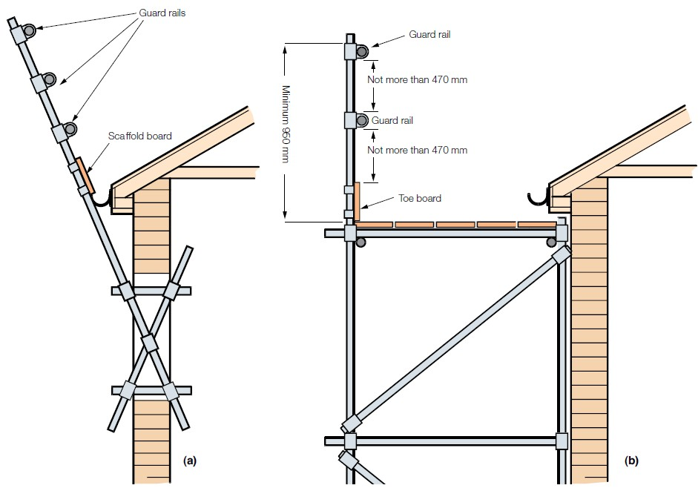

Figure 6(a), (b) – edge protection types.

5.7 Harness/lanyards

Harness and lanyards are personal protective measures for fall prevention and should be considered when the risk of falling is higher than expected. A regime for the inspection & records of harnesses/lanyards must be established and include:

- The unique identification and type of harness/lanyard
- The frequency and type of inspection (pre-use checks, detailed inspection and where appropriate, interim inspection)
- Competent persons carrying out the inspections
- Action taken to rectify defects
- Means of recording the inspections
- Training of users; and
- A means of monitoring the inspection regime

Note: A lanyard which has arrested a fall must be withdrawn from use immediately.

5.8 Tallescopes

Tallescopes are a method for working at height in theatres, however they should not automatically be regarded as the default option for access.

They benefit by allowing height adjustments being readily made whilst positioned on stage and being highly manoeuvrable. In general, a tallescope provides a working place for one person in a cage.

As with all assembled working at height equipment, manufacturer’s instructions must be followed in its construction and staff be formally trained in this and its use. A minimum of 3 people are recommended when using tallescope.

For further information on the safe use of Tallescopes go to: Code of practice for use of Tallescopes for working at height in theatres, ABTT 2014

Note: Tallescopes must never be used without the outriggers being deployed and must never be moved whilst people and materials are on the working platform.

5.9 Emergency Rescue Procedures

Emergency procedures must be considered for circumstances such as stuck access equipment and deployed fall arrest systems, to allow rescue of a person(s). There must be a plan that outlines how someone would be recovered should they fall. The rescue plan should include:

- Details of the rescue equipment to be used
- Configuration of the equipment for different types of rescue
- Identification of anchor points where necessary
- Limitation of the plan for adverse weather
- The need for trained rescue personnel

When planning rescue procedures there shouldn’t be a reliance on the emergency services. It should be a simple process such as lowering someone from a deployed lanyard or using a ladder to retrieve a person from a net. Once a rescue has been achieved, first aid procedures should take over, including the use of a horizontal recovery position where necessary.

6. INSPECTIONS

6.1 Inspections of ladders and stepladders

A trained and competent person(s) will carry out a detailed inspection covering the overall condition of ladders and stepladders:

    - 12 monthly for non-professional or infrequently used ladders/stepladders
    - 6 monthly for professional ladders/stepladders and frequently used ladders
    - 3 monthly for frequently used professional ladders/stepladders within Housing Asset Services
    - After repair/modification
    - After any accident/incident

It should be noted that a detailed inspection may be required at more frequent intervals where the items are subject to heavy use or if required by the manufacturer’s requirements.

Appendix 1 provides guidance of the component parts which should be inspected, whilst Appendices 2 and 3 provide checklists for the inspection of ladders and stepladders.

6.2 Visual inspection by user

The person using the ladder must carry out a visual inspection:
    - For obvious damage or faults before use and before returning to the equipment store
    - After any incident where the equipment could have been damaged

Note: Defective equipment must not be used and must be removed for repair and reported to the appropriate Manager/Officer until a repair or disposal is complete.

Equipment inspections must be undertaken by a competent person at specified intervals and after exceptional circumstances. Exceptional circumstances would include:
    - Poor weather conditions such as high winds, excess snow or ice
    - Unauthorised access of the equipment or anything else that may compromise the integrity of the equipment
    - Following an incident

Any working platform used for access or used during construction work of 2 metres or over must be inspected by a competent person whilst it is in place, and every seven days as a minimum or more frequently if the exceptional circumstances apply.

A thorough inspection regime must be put in place for all mechanical equipment carrying people, whilst working at height. This statutory inspection must be undertaken on a six monthly basis. All other equipment must be inspected prior to use and as specified by manufacturers guidance. All inspections must be carried out by a competent person, with records appropriately kept.

For mobile platforms, inspections must be carried out every time the platform is moved to check the stability of the ground conditions etc.

Inspection records must be maintained in a Register and kept at site, or where there is no site office; in a central location until the work is completed. Where any project comes under the requirements of the Construction (Design and Management) Regulations 2015, records must be kept for three months following the end of the project.

All equipment used for the purpose of working at height that has a requirement under the Lifting Operations and Lifting Equipment Regulations 1998 must have a thorough inspection as defined within these Regulations.

6.3 Inspection Recording

On completion of the detailed inspection the following information must be recorded:
    - Details of the inspection date and next inspection marked in the Register
    - Details of any defects and repairs entered in the Register
    - The item marked with an appropriate identification tag or marking to confirm its safety
    - The item clearly marked as defective, where required

6.4 Inspection of existing places of work

In existing places where working at height is being undertaken i.e. roofs etc., regular checks of the working area must be carried out before and during use. This includes checks of the following:
    - Condition of surface – check for fragile surfaces
    - Parapets
    - Permanent rails or other fixed fall preventative measures
    - Fixed access/egress arrangements e.g. fixed ladders etc.
    - Housekeeping on working platforms
Always look for obvious defects:
    - Corroded/missing guard rails
    - Holes in floor/missing boards (ramps)
    - Missing/damaged valley gutter or protection for fragile surfaces
    - Missing signage identifying fragile surfaces

7. INFORMATION, INSTRUCTION & TRAINING

Employees authorised to use and/or inspect any types of working at height equipment must receive appropriate information, instruction and training in their use.

To establish competency it is recommended that sections nominate and train designated employees intended to use and/or inspect working at height equipment i.e.
- Ladder Inspection Course
- MEWPs - Operators using MEWPs must be appropriately trained and certified i.e. IPAF certificate or similar, and carry their card at all times. Any person operating a MEWP must be re-trained appropriately at a time specified not exceeding 5 years but determined by the risk profile of the work being undertaken.
- Using mobile scaffold platforms – typically users should be trained in PASMA or similar.
- Scaffold inspection course – to allow handover and 7 day inspections to be carried out on fixed scaffolds.

Note: Employees that haven’t received the relevant information, instruction and training are prohibited from using working at height equipment.

8. FURTHER INFORMATION

8.1 Contact Information
Health & Safety Strategy Group, East Ayrshire Leisure Trust
E Mail: EALHealthandSafety@eastayrshireleisure.com
Intranet: Health & Safety

Health and Safety Section, East Ayrshire Council
E Mail: healthandsafety@east-ayrshire.gov.uk
EAC Intranet Health and Safety

8.2 External sources of information

Further useful information for managers when planning or carrying out work at height can be found in a variety of widely available HSE guidance documents and information sheets, including the following:

HSE Work at Height website

Work at Height 2005, a Brief Guide

Working on Roofs

Inspecting Fall Arrest Equipment

Appendix 1

LADDER/STEPLADDER INSPECTIONS REQUIREMENTS

The general condition of the ladder must be inspected with particular attention given to the following:

- Condition of rungs or treads.

- Condition of stiles, wear at head and feet, and end grain protection.

- Fastenings (rivets, screws etc.)

- Condition of tie rods.

- Lack of rigidity, excessive ‘play’ between stiles and rungs, warping or sagging.

- Condition of wire reinforcement in stiles.

- Sharp edges on stiles and treads.

- Condition of ropes, cords and pulleys (correct length of rope).

- Presence of lubrication on moving parts.

- On stepladders and trestles, condition and lengths of spreader, conditions of hinges, swivels and sliding joints, presence of lubrication.

- Aluminium ladders should be carefully checked for twisting or distortion by sighting along the stiles and also for excessive oxidisation or excessive corrosion. The presence of such defects makes an aluminium ladder potentially dangerous to use.

- Aluminium ladders should carry a warning “Not to be used near electrical equipment or supply”.

- Extension locks.

- Anti slip bases.

- Ridge locks and wheels.

- Departmental identification markings.

- Associated equipment certification attachments.

Appendix 2

LADDER INSPECTION CHECKLIST

Location of Ladder |  | Ladder Reference/ ID Number
Section |  | Inspected By

Part of Ladder |  | Areas to check | Satisfactory | Unsatisfactory | N/A | Comments
1 | ID markings | missing or illegible
2 | Stiles | cracked, split, worn or broken
3 | Stiles | twisted, distorted or sharp edges
4 | Rungs | cracked, split, worn or broken
5 | Rungs | loose (can be moved by hand)
6 | Rungs | twisted, distorted or missing
7 | Plugs | damaged, worn or missing
7 | Clutch | damaged, worn or missing
8 | Fittings | rusted, corroded, damaged, worn or missing
9 | Fasteners | rusted, corroded, damaged, worn or missing
10 | Ropes | damaged, deteriorated, missing
11 | Feet | missing, damaged, anti slip bases
12 | Aluminium Ladders | Warning not to be used near electrical equipment or supply

Action Required | Completed

Appendix 3

STEPLADDERS INSPECTION CHECKLIST

Location of Stepladder |  | Stepladder Reference/ ID Number
Section |  | Inspected By

Part of Stepladder |  | Areas to check | Satisfactory | Unsatisfactory | N/A | Comments
1 | ID markings | missing or illegible
2 | Stiles | cracked, split, worn or broken
3 | Stiles | twisted, distorted or sharp edges
4 | Treads | cracked, split, worn or broken
5 | Treads | loose (can be moved by hand)
6 | Bottom diagonals | loose or missing
7 | Bottom diagonals | twisted or distorted
8 | Rubber feet | damaged, worn or missing
9 | Rivets | loose or missing
10 | Aluminium Ladders | Warning not to be used near electrical equipment or supply
REAR SECTION
11 | Rear leg angles | cracked, split, worn or broken
12 | Rear leg angles | twisted or distorted
13 | Cross angles | cracked, split, worn or broken
14 | Top hinge | worn or broken
15 | Rivets | loose or missing
16 | Side stabilisers | worn or broken
17 | Side stabilisers | twisted or distorted

Action Required | Completed

