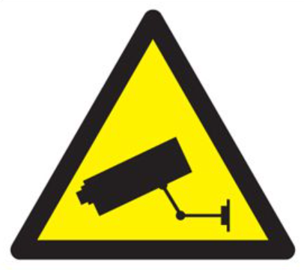

24 hour CCTV in Operation
Your safety is important, closed-circuit television system is operated on these premises for the purpose of prevention and detection of crime, safety and good management.
This scheme is controlled by:
East Ayrshire Leisure & East Ayrshire Council
For further information contact:
Risk Management Centre – 01563 553950

