
Ayrshire360 uses an online electronic Accident/Incident reporting system called SHE Assure (Evotix) to record all workplace health and safety accidents and incidents.

Reporting on SHE
Anyone can access the SHE system to report an accident or incident – you do not need an account. If you need to report an accident or incident, please go to https://app.uk.sheassure.net/ea/p/portal/ where you will be able to input the information.

To report an accident or incident through your mobile device, click on the QR code below. Simply open the camera on your device, scan the QR code and this will take you to the SHE Assure reporting page where you can input the details:

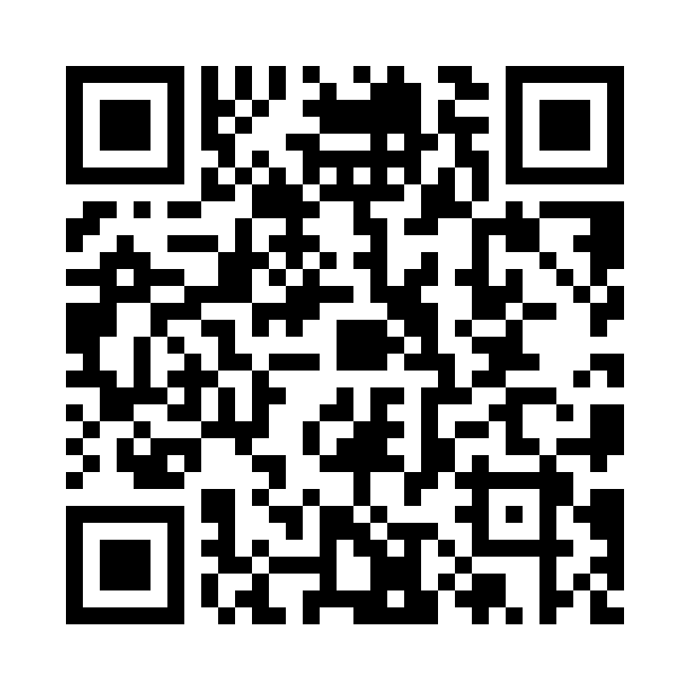
Managers
If you require to update and/or add information to accidents or incidents which have been reported on SHE, you can access the system at https://uk.sheassure.net/ea.

Training
An e-learning module for the SHE Assure system is available on Learnpro. All employees must complete this course before inputting any details on the system. SHE User Guides are available on the SHE System Incident Reporting page. Further information on incident reporting procedures are available within the Incident Reporting Standard.

It must be remembered that when inputting to or using the SHE System you may have access to confidential employee and non-employee information. In line with the Trust’s Data Protection Policy, you have responsibility to treat information responsibly and confidentially at all times. Any breach or loss of sensitive or confidential information may lead to disciplinary action being taken against the employee concerned.

HEALTH AND SAFETY BULLETIN
REPORTING ACCIDENTS AND INCIDENTS ON SHE ASSURE

